Шифр-------------------------------------------
Муниципальная «Малая предметная олимпиада»
по английскому языку для учащихся 4 класса

Максимальное количество баллов-64.
Время выполнения работы 60 минут.

Task I. Ник и Энн рассказывают о своих школах.
Прочитай и сравни их. Максимальный балл 7.
Время выполнения- 10 минут.
Nick: My school is big. It has got three floors. There are nine hundred pupils in it. We have got a lot of classrooms, a library, a cafeteria, a hall and a gym in our school.
Our classrooms are very comfortable. There are desks, chairs, bookcases and computers there.
Sometimes I go to the library. There are a lot of books there. I take books home or read books in the reading room.
There is a sports ground near my school. We usually play football there. We have got a gym, too. It is very light and there are a lot of balls there.
I like my school very much because it is a nice place indeed.
Ann:
I live in the country. Our school is not very big. There are only two hundred pupils in my school. There are seventeen classrooms in my school. There is a playground and a garden in my school. We have got a library, a hall and a cafeteria, too.
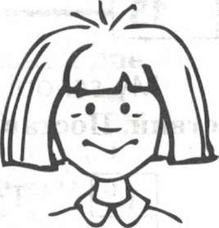
There are fifteen pupils in every class. Our classrooms are not very big. There are eight desks, a blackboard, a teacher's table and a bookcase in our classrooms.
The garden is near our school. There are a lot of trees and flowers in it. We plant and water them.
Our playground is fantastic. We have P.E. on the playground. We run, jump and play games there.
My school is so fine. I like to go to my school! And I like my classes very much!

Отметь, о чьей школе идет речь. Поставь букву N или А.
Who has got | Nick or Ann?
1.a lot of classrooms?
2.a big school?
3.a small school?
4. 17 classrooms?
5. a playground?
6. a garden?
7. a gym?

Task II. Прочитайте предложения и отметьте, являются ли они верными (True) или неверными (False). Максимальный балл 7.
Время выполнения- 10 минут.
- There are 800 pupils in Nick’s school.
- True B. False
- There are 15 pupils in every class in Ann’s school.
A. True B. False
- Nick sometimes goes to the library.
- True B. False
- In Ann’s school pupils do sports in the garden.
- True B. False
- Nick and his classmates usually play basketball on the sports ground.
- True B. False
- Ann has P.E. on the playground.
- True B. False
- Nick likes his school.
- True B. False

Task III.
Look at the picture. Where are the kids and animals? Put in the prepositions. Use every preposition only once. Максимальные баллы- 6.
Время выполнения- 7 минут.
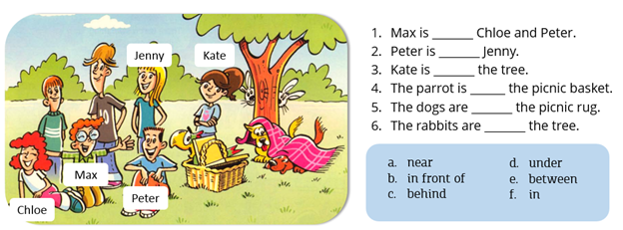

Task IV. Complete the sentences with the given tense forms of the verbs.
Максимальные баллы- 6.
Время выполнения- 7 минут.

1. He _____several mistakes in his report yesterday. a) is making
2. She _______a delicious dinner now! b) has made
3. George _____his bed every morning. c) will make
4. He ___ already ___ plans for the summer. d) made
5. I ________an appointment with the dentist next week. e) make
6. Close your eyes and ____a wish! f) makes

Task V. Read the e-mail and mark the sentences T (true), F (false) or No information (NI)
Максимальный балл- 5.
Время выполнения- 12 минут.

From: Sharon
To: Helen
Dear Helen,
Thanks for the birthday card! I’m really looking forward to the weekend. I’m going to have a party on Saturday night.
Mum and I are going to go shopping on Saturday morning. We want to buy some food and decorations for the party. Mum’s going to make her special pizza and a birthday cake. I am going to make sandwiches. In the afternoon, my brother is going to help me decorate the house with streamers. Then, I’m going to help my mum clean-up.
Well, I think it’s going to be a great party. How are you going to spend your weekend? Write soon.
Love,
Sharon

Circle the right answer.
- Sharon’s birthday is on Saturday.
T (true), F (false), No information (NI)

- They’re going to go buy a birthday cake.
T (true), F (false), No information (NI)

- Sharon is going to decorate the house in the afternoon.
T (true), F (false), No information (NI)

- Sharon doesn’t like the rock music.
T (true), F (false), No information (NI)

5 The party is going to finish on Sunday morning.
T (true), F (false), No information (NI)

Task VI. Прочитайте слова, распределите их по категориям.
Максимальные баллы- 29.
Время выполнения- 12 минут.

(pupil, sweater, gymnastics, kitchen, hat, hamster, pen, football, potato, ping-pong, butter, dress, book, golf, mouse, tennis, dog, parrot, banana, cat, shoes, apple, jeans, socks, duck, door, monkey, lion, TV-set)

Food

House

Sports

School

Animals
Clothes

Task VII. Время выполнения- 1 минута. Максимальные баллы- 2.
Разгадай шараду:
1. Скажешь по-английски —
Тебя он повезёт,
А по-русски если —
Певец им запоёт.

Task VIII. Время выполнения- 1 минута. Максимальные баллы-2 .
Как можно сформулировать вопрос, чтобы ответ на него звучал следующим образом:
Twenty-five past eleven?

Перенеси ответы в Лист ответов учащегося

Лист ответов учащегося 4 класса
Task I.
Who has got...? | Nick or Ann?
1.
2.
3.
4.
5.
6.
7.

Task II. True or False
1
2.
3.
4.
5.
6.
7.
Task III.
1 | 2 | 3 | 4 | 5 | 6
Task IV.
1 | 2 | 3 | 4 | 5 | 6
Task V.
1 | 2 | 3 | 4 | 5

Task VI.
Food — ______________________________________________________________________
House — _____________________________________________________________________
Sports — _____________________________________________________________________
School — _____________________________________________________________________
Animals — ____________________________________________________________________
Clothes — ____________________________________________________________________

Task VII.
_________________________________________________________________

Task VIII.
__________________________________________________________________

